Chapter 17, Solution 28.

Obtain the trigonometric Fourier series for the voltage waveform shown in
Fig. 17.66.
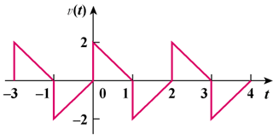

–2

Figure 17.66
For Prob. 17.28.

Solution

This is half-wave symmetric since f(t − T/2) = −f(t).

a_{o} = 0, T = 2, ω_{o} = 2π/2 = π

a_{n} =

=

= [4/(n²π²)][1 − cos(nπ)] = 8/(n²π²), n = odd
0, n = even

b_{n} =

=

= 4/(nπ), n = odd

f(t) = , n = 2k − 1

